Bottle cap spelling mat

-Use your alphabet bottle caps to spell CVC words

-Print the Bottle Cap Spelling Mat (1 for each student at station) & CVC pictures onto cardstock and laminate for durability

\*To make this activity self-checking, write the word on the back of each laminated picture

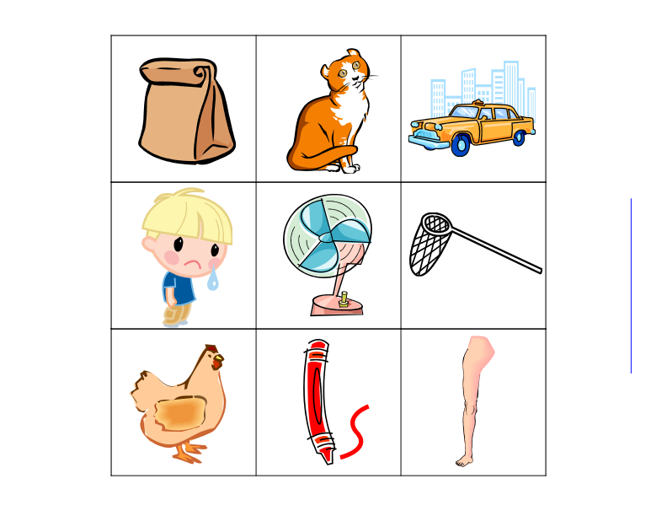 (

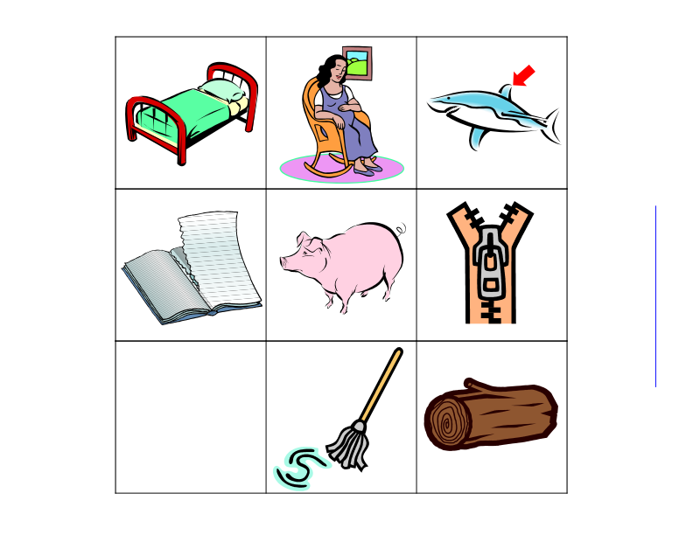

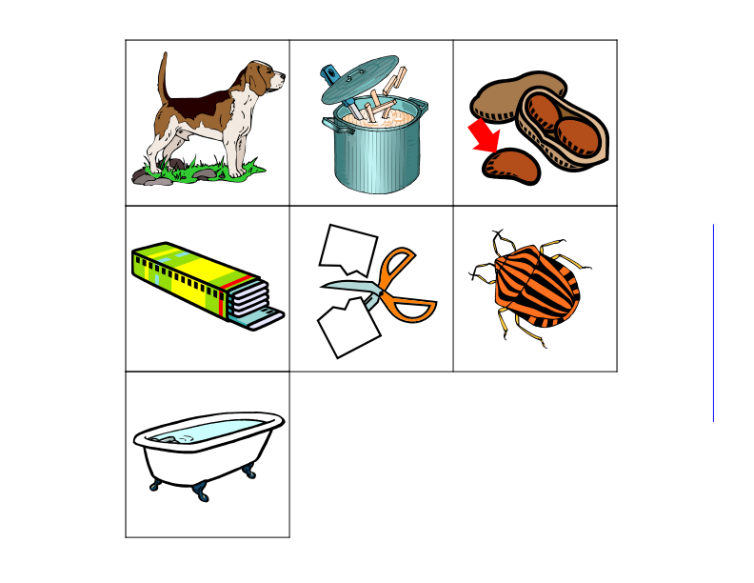

*Picture Key:*

*Short a: bag, cat, cab, sad, & fan*

*Short e: net, hen, red, leg & bed*

*Short i: sit, fin, rip, pig, & zip*

*Short o: not, mop, log, dog, & pot*

*Short u: nut, gum, cut, bug, & tub*

*\*Adapted from thisreadingmama.com*